Health and Safety Plan

For The Parish of …………………………………..

(“The PARISH”)
Catholic Diocese of Hamilton

September 2016

Table of Contents
- Health & Safety Statement
- Health and Safety Policy
  - Preamble
  - Purpose
  - Coverage
  - Duties under the Act
  - Management responsibilities
  - Worker responsibilities
  - Worker engagement and participation
  - Reporting on health and safety
  - Related policies
- Reporting Procedures
- Training and Induction
  - Overview
  - Template: Training Register
- Risk Management
  - Overview
  - Hazard Identification Process
  - Risk Assessment
  - Hazard Identification Flowchart
  - Template: Hazard Notification Form
  - Template: Hazard Identification Form
  - Template: Working Bee Checklist
  - Annual H&S Review Plan
- Emergency Management
  - General
  - Emergency Procedures
  - Template: Evacuation Plan - Testing Record
- Incident Management
  - Overview of Incident Management
  - Notification of Incidents
  - Template - Notifiable Death/Injury/Illness
  - Template - Accident Investigation Form
- Visitor and Contractor Management
  - Overview
  - Definitions
  - Responsibilities
  - Contractor Selection
  - Contractor Health & Safety Management
- Building Safety
  - Template: Building Safety Checklist
- Individual Policies
  - Health & Safety Policy
  - Discomfort/Pain/Injury (DPI) Prevention Policy
  - Smoke-free Policy
  - Stress at Work Policy
  - Lock-up Policy
  - Safe Driving Policy
  - Harassment & Bullying Policy
  - Disruptive Persons Policy
  - Manual Handling Policy
  - Rehabilitation Policy
  - Risk Assessment Management Examples
    - Encounter Day - CYO Bush Walk
    - SetFree Catholic Youth Festival

Health & Safety Statement
The PARISH believes that an effective health and safety management system is the key to a successful organisation; ethically, morally, spiritually, legally and financially. Through our active commitment to legislation, compliance and most importantly ensuring our workers and Church are safe, we will continuously look for opportunities to improve our performance and systems whilst still following our Church values.
We aim to actively promote improvement through ensuring our workers and management are equally committed, involved and supportive of our health and safety practices.
To achieve this we will ensure all workers and visitors are:
- Working together; taking reasonably practicable steps to ensure that any significant risks or hazards to workers are minimized, and workers are protected, where elimination is impracticable.
- Involved in identifying and controlling new and existing hazards and regularly monitoring these hazards within our facilities.
- Informed about accident and emergency procedures.
- Aware of their responsibilities to themselves, their fellow workers and the general public.
- Utilising the systems in place to record all incidents, near misses or injury.
- Promoting the provision of advice, information, education and training in relation to work health and safety.
Authorised and reviewed by: |  | Signature:
 |  | Full Name:
 |  | Position:
 |  | Date:

Health and Safety Policy

Preamble
The PARISH is committed to providing a safe and healthy workplace for all its workers (including volunteers), visitors and contractors, and to providing the information, training and supervision needed to achieve this.
Health and safety is a shared responsibility. The PARISH is responsible for the development and implementation of the Health and Safety Policy, procedures and processes. Workers must take personal responsibility for promoting and protecting their own health and safety and that of their colleagues by complying with The PARISH policies and procedures.

Purpose
The purpose of this Policy is to:
(a) Ensure that the management of health and safety is consistent with:
Catholic social teaching on work and the dignity of the person;
The PARISH legislative requirements under the Health and Safety at Work Act 2015 (‘The Act’); and
The PARISH intention to be a good employer.
(b) Outline responsibilities; and
(c) Minimise The PARISH’s exposure to risk.

Coverage
This Policy covers those workers and contractors at The PARISH who work in the Catholic Diocese of Hamilton, other diocesan centres, from home, or in another location listed in the Employee’s Employment Agreement.

Duties under the Act
In accord with section 17 of The Act the ‘person conducting a business or undertaking’ (PCBU) is The PARISH of the Catholic Diocese of Hamilton, which has the duties set out in section 37 of The Act.
The Officers of the PCBU have the duties set out in section 44 of The Act. The Officers are the Parish Priest and the [name of designated Parish H&S Officer].
Workers have duties as defined in section 45 of The Act.
Other persons at the workplace have the duties set out in section 46 of The Act.

Management responsibilities
The management of The PARISH is committed to providing and maintaining a safe and healthy working environment for its workers, visitors, and all persons using the premises as a place of work.
To ensure a safe and healthy work environment management will develop and maintain a Health and Safety Management System. Specifically, management will:
- Set Health and Safety objectives and performance criteria for all Managers and work areas.
- Annually review Health and Safety objectives and Managers’ performance.
- Actively encourage the accurate and timely reporting and recording of all incidents and injuries.
- Investigate all reported incidents and injuries.
- Investigate all reported incidents and injuries to ensure all contributing factors are identified and, where appropriate, plans are formulated to take corrective action.
- Actively encourage the early reporting of any pain or discomfort.
- Provide a treatment and rehabilitation plan that ensures a safe, early and durable return to work.
- Identify all existing and new hazards, and take all reasonably practicable steps to eliminate or minimise the exposure to any hazards deemed to be significant.
- Ensure that all workers are made aware of the Hazards in their work area and are adequately trained to enable them to perform their duties in a safe manner.
- Encourage worker consultation and participation in all matters relating to Health and Safety.
- Enable workers to elect Health and Safety Representatives.
- Promote a system of continuous improvement, including the annual review of policies and procedures.
- Meet our obligations under the Health and Safety at Work Act 2015, Health and Safety Regulations, Codes of Practice, and any relevant Standards or Guidelines.

Worker responsibilities
Every worker is expected to share in the commitment to health and safety. Every manager has a responsibility for the health and safety of those workers under their direction.
Every worker is expected to play a vital and responsible role in maintaining a safe and healthy workplace through:
- Observing all safe work procedures, rules and instructions.
- The early reporting of any pain or discomfort.
- Taking an active role in the company’s treatment and rehabilitation plan, to ensure an “early and durable return to work”.
- Ensuring that all incidents, injuries and hazards are reported to the Manager.

Worker engagement and participation
Engagement with workers on health and safety is to take place:
- Immediately, once this policy is approved.
- When any of the circumstances in Section 60 of The Act arise.
- When health and safety performance objectives are set.
In the engagement process, relevant information is to be shared with workers in a timely manner. They are to be given a reasonable opportunity to express their views and to raise work health or safety issues in relation to the matter; and to contribute to the decision-making process. The views of workers are to be taken into account by The PARISH and the workers are to be advised of the outcome of the engagement in a timely manner.

Reporting on health and safety
There are to be procedures in place for incident reporting and general reporting on health and safety matters.

Related policies
The PARISH will develop and maintain work-related health and safety policies.

Reporting Procedures
The following procedures are to be followed in relation to reporting on health and safety:
Incident reporting: accidents/incidents and near misses are to be reported to the [NAME of designated person] as soon as possible after they occur, and are to be recorded by the Receptionist in the PARISH Accident/Incident Log. Records are to be kept for five years. Workers must report ongoing or slow development issues such as repetitive strain or stress as soon as they become aware of the problem.
General reporting: a Health and Safety Report is to be on the agenda of the parish Finance/Property Committee meetings.

Training and Induction

Overview
All existing workers should be appropriately trained and inducted into the health and safety system as well as all new workers as they are employed, to ensure they understand and are aware of any risks or hazards. Also, to ensure they understand the processes involved and what their responsibilities are as an Officer, or as an individual. Note that this includes any worker transferring to a new role or task.
Ensure that:
- H&S information, specific to the workplace, is available to all workers.
- Supervision to ensure they do not endanger themselves, others or equipment.
- Key messages are understood; adapted for language, literacy, ethnicities, culture, vision
WORKER ENGAGEMENT AND PARTICIPATION
- Forum is held for open communication and consultation.
- Put processes in place for development, monitoring and review.
- Workers are engaged and understand importance of their actions or inactions in relation to health and safety
- Involve all workers at all levels, through team meetings.

TRAINING REGISTER
A register must be kept of all training, especially the H&S Training of the Officers and other workers. This should be reviewed annually to ensure their training is up to date and when certificates require renewing.

Template: Training Register
Training Register
Training Topic/Course Name | Names of people attending | Date Completed | Date to Renew
First Aid
Health & Safety Course
Counsellor Training
Family Assistance Training
Fire Warden Training

Risk Management

Overview
Risk analysis is about keeping your workers and visitors safe by following processes to assess risks and hazards in the workplace. Once you assess the hazards, we identify what impact these will have and how likely they may occur.
It is The PARISH as PCBU’s responsibility to take all reasonably practicable steps to ensure that all hazards are identified, analysed and actions are taken to eliminate, isolate or minimise any harm that could come from them.
Accountability must be shown and plans and dates made to complete action. Discussing these in team meetings ensures everyone is aware and action can be followed up and noted for the file.
If there is a high health and safety risk, then The PARISH (as PCBU) must show what actions they have done to identify, assess, eliminate or minimise and also how they advise workers and visitors to ensure they are aware.
This is called the Hierarchy of Control – utilising these following steps of Likelihood,
Impact, and the Priority Chart to analyse which hazard has the highest risk and whether or not immediate action must occur to remedy this. Once actions have taken place, then a follow up assessment will identify if the actions have reduced the risk.
The following pages have an easy chart to show how to analyse this and your Hazard Register, which is a living document for you to list, amend and delete as you eliminate your hazards and risks. Some hazards will remain on the list and you will have minimised the risk, but they still must be recorded and monitored.

Hazard Identification Process
(a) Use inspection, audits, walk-through surveys and checklists to determine hazards.
Hazard Identification Factors
Environmental factors | Human factors | Task/activity factors
Working environment | Health, disability, fitness | Task analysis
Area used and its physical condition | Protective clothing. equipment, footwear | Working posture and position
Workplace layout | Manual handling | Duration and frequency of tasks
Location of material/equipment and distances moved | Correct use of equipment (training) | Loads and forces involved
Types of equipment used |  | Repairs and maintenance
Energy hazards
Hazards that could cause injury
Hazards that could cause ill health
Organisation culture

(b) Analyse any ‘near miss’ accidents that may have been recorded in the Incident and Accident register or documented in the minutes from health and safety meetings.

Risk Assessment
Risk assessment is the process of estimating the magnitude of the risk and deciding what actions to take. The following considerations are made to establish risk using the Likelihood Scale and Impact Scale tables below:
Likelihood Scale
Scale | Score | Frequency of Accident or Illness | Chance of  Occurring
Rare | 1 | May occur only in exceptional circumstances | < 5%
Unlikely | 2 | Could occur at some time | 5.29%
Moderate | 3 | Should occur at some time | 30-59%
Likely | 4 | Will probably occur in most circumstances | 60-79%
Almost certain | 5 | Will occur in most circumstances | >80%

Impact Scale
Scale | Score | Frequency of Accident or Illness
Insignificant | 1 | Negligible injury or illness
Minor | 2 | Minor injury or illness requiring minor first aid and/or less than 1 week’s recovery.
Moderate | 3 | Injury or illness requiring advanced first aid and medical visit (e.g. GP or hospital visit) and/or 1 - 6 weeks’ recovery.
Major | 4 | Injury or illness requiring advanced first aid and emergency medical assistance (e.g. hospitalisation) and/or more than 6 weeks’ recovery.
Catastrophic | 5 | Injury or illness requires immediate emergency medical assistance and may result in permanent or long-term disabling effects or death. Hospitalisation likely to e for more than 6 weeks’

A risk assessment category (critical, high, moderate, or low) for each hazard is compiled by using the chart below.
Notes:
Hazards with the highest rating are given priority.
Any risk score greater than moderate is deemed to be a significant hazard.
Impact x Likelihood = Priority
Impact | Summary Priority Profile
Impact | 5 | 10 | 15 | 20 | 25
Impact | 4 | 8 | 12 | 16 | 20
Impact | 3 | 6 | 9 | 12 | 15
Impact | 2 | 4 | 6 | 8 | 10
Impact | 1 | 2 | 3 | 4 | 5
 | Likelihood

Priority Chart
Priority score | Priority rating | Action required
0 - 1 | Very low | Recognise that risk exists but continue with activity
2 - 3 | Low | Consequences are insignificant. Manage by regular monitoring
4 - 9 | Medium | Consequences may be unacceptable and need management action to share and/or reduce likelihood/impact.
10 - 16 | High | Consequences are unacceptable and need immediate management action to share and/or reduce likelihood/impact.
17 - 25 | Very High | Consequences are too great. Continue only if there is a statutory duty or with approval of executive team.

Hazard Identification Flowchart

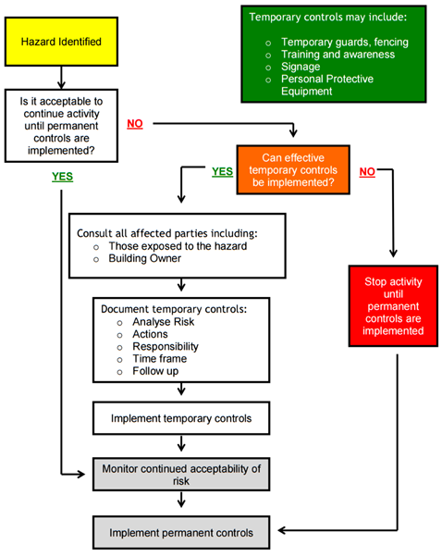

Template: Hazard Notification Form
Hazard Notification Form
Name of Notifier: |  | Location: | Notification given to:
Description of hazard including your opinion of significance:
What immediate action was taken to mitigate (please describe, if any):
Your recommendations to control or eliminate the hazard:
Signature (Notifier): |  |  | Date: / /
Health and Safety Representative Assessment
[LIKELIHOOD] x [IMPACT] = [PRIORITY]
[ ] x [ ] = [ ]
Comment (if applicable)
Date (when H&S Rep enters hazard/updates the Hazard Register) / /
Signature (Manager/nominated person) / / Date
Note: This form should be used when workers identify a new hazard, or if a current hazard in the hazard register is thought to be incorrectly managed to eliminate or mitigate the risk.

Template: Hazard Register
List Name of Hazard and the  controls required (incl existing) | Significant hazard? | Practicable to Eliminate,  Isolate or  Minimise | Person  responsible | Due date | Date Completed  and  initials
 | Y or N | E or I or M | Person  responsible | Due date | Date Completed  and  initials
1
2
3
4
5
6
7
8
9
10

Template: Working Bee Checklist
Working Bee Checklist
BEFORE THE DAY TIP: Take photos to record the event/work completed for Church Newsletter/website
What work is required to be done?
Do you have sufficient people?
Do you have the correct tools for the jobs?
Is any special protective gear required?
Do you need specialist tradespeople – are these available through your volunteers?
How long will each job take?
How skilled do volunteers need to be?
Is there equipment being used that requires training (e.g. a cherry picker)?
Is there a skip for rubbish disposal or some other means?
Is there a need for Police Vetting?
Is supervision of children necessary and if so, has this been arranged?
Are food and refreshments required and if so, has this been arranged?
If the working bee is cancelled, how will you communicate this?
ON THE DAY
Have all volunteers been briefed? (eg thank them; advise jobs required, safety requirements, incl any hazards, what is required for the day; who to report to; how to fill out incident reports, where the first aid kit is and who is first aid trained?)
Have you ensured volunteers are fit for the job they are doing (eg the oldest volunteer shouldn’t be lifting the heaviest table/equipment)?
Have you ensured volunteers understand what is required?
Have supervisors been delegated to ensure their training, safety and understanding?
Are regular breaks scheduled and are fluids available? (eg water, cup of tea)
Has sunscreen been provided for those working outside?
Are you consulting, co-operating and coordinating with volunteers throughout the day? (To help with this, ask other leaders to assist, but have one overall person in charge.)
END OF DAY
Has a debrief been organised with volunteers? (eg talk about what was achieved, any issues, etc)
Review practices - what could be done differently?
Document recommendations - has a record been kept so improvements can be made next time?

Annual H&S Review Plan
Annual Health and Safety Review Plan
Health & Safety System | Policy Components | Review  timeline
Employer commitment  to health and safety | Review outline of health and safety programme (objectives) | Yearly
Employer commitment  to health and safety | Review employer commitment including and employee responsibilities | Yearly
Employer commitment  to health and safety | Volunteers | As required
Employer commitment  to health and safety | Acknowledgment of and cross-reference to relevant legislation | Yearly
Employer commitment  to health and safety | Check quality systems that support health and safety such as internal audit | Yearly
Hazard identification  and management | Hazard identification process and risk analysis | Quarterly
Hazard identification  and management | Managing hazards | As required
Hazard identification  and management | Manual handling training | Quarterly
Hazard identification  and management | Check forms for hazard identification and analysis available | Monthly
Accident reporting and  management | Review definitions of accident and serious harm | Monthly
Accident reporting and  management | Review procedures for investigating and recording accidents | Monthly
Accident reporting and  management | Check forms for recording accidents and investigations available | Monthly
Emergency planning  and readiness | Check first aid supplies | As required
Emergency planning  and readiness | Review disaster management plan | Yearly
Emergency planning  and readiness | Practice emergency plan | Yearly
Worker information,  training & supervision | Induction process and training | As required
Worker information,  training & supervision | Worker responsibilities | As required
Worker information,  training & supervision | Review ongoing training and worker development plan | Yearly
Worker involvement | Review employee participation | Monthly
Worker involvement | Cross reference to health and safety issues in all team meetings | Monthly
Contractors and visitors | Definitions | As required
Contractors and visitors | Processes to ensure safety while on-site | As required
Contractors and visitors | Responsibilities | As required
Event management | Health and safety off-site | As required
Event management | Responsibilities and functional relationships with other stakeholders | As required
Event management | Checklists managing risk – event management | As required

Emergency Management

General
Documented emergency plans must identify any potential situation that meets the relevant emergency service requirements. Once practiced, all emergency procedures should be debriefed and continuous improvement noted and shared with the group.
Plans must be implemented and communicated to The PARISH.
Designated fire wardens and first aiders are essential.
Emergency signage should be clear and obvious.
Periodic testing of emergency procedures (trial evacuation) should be:
- Documented and verified
- Debriefed and areas of improvement noted for the next drill
- Communicated to workers - post event
DO I NEED AN APPROVED EVACUATION SCHEME?
A building owner must ensure the building complies with the Fire Service Act 1975 ("Act") and the Fire Safety and Evacuation of Buildings Regulations 2006 ("Regulations").
Some buildings, if used in whole or part for one or more of the following purposes, must have an approved evacuation scheme:
- The gathering together, for any purpose, of 100 or more persons
- Providing employment facilities for 10 or more persons (see note also)
- Providing accommodation for more than 5 persons (other than in 3 or fewer Household units) (see note also)
- A place where hazardous substances are present in quantities exceeding the prescribed minimum amounts (set out in schedule 2 of the regulations), whatever the purpose for which the building is used
- Providing early childhood facilities (other than in a household unit)
- Providing nursing, medical, or geriatric care (other than in a household unit)
- Providing specialised care for people with disabilities (other than in a household unit)
- Providing accommodation for persons under lawful detention (not being persons subject to home detention)
Note: Owners of buildings with an automatic sprinkler system (which meets the criteria set out in the regulations) and which are only used for either 2 or 3 (but not both of those uses) do not need an approved scheme. However, owners of those buildings must give the National Commander notice that the building does not need an evacuation scheme, in the form set out in the regulations notification, that a scheme is not required.
REFERENCE
https://onlineservices.fire.org.nz/Home/EvacuationSchemes#DoIneedanevacuationscheme
VOLUNTARY SCHEME
If the building is not a relevant building because it is not used for one or more of the uses listed in section 21A of the Fire Service Act 1975, then the application is voluntary. Owners of buildings that are not relevant buildings may apply for Fire Service approval of an evacuation scheme.
EVACUATION PROCEDURE
An evacuation procedure is a plan that describes how occupants will escape to a place of safety if there is a fire (or suspected fire).
Evacuation procedures do not need Fire Service approval. The requirements for evacuation procedures are set out in Part 1 of the Fire Safety and Evacuation of Buildings Regulations 2006. Most buildings other than dwellings must at least have an evacuation procedure in place, but if a building is a relevant building (see FAQ 'What is a relevant building?') then the building owner must provide and maintain an approved evacuation scheme.
RELEVANT BUILDING
Under section 21A of the Fire Service Act 1975 relevant building means a building or part of a building used for one or more of the following purposes:
- The gathering together, for any purpose, of 100 or more persons;
- Providing employment facilities for 10 or more persons;
- Providing accommodation for more than 5 persons (other than in 3 or fewer household.
- A place where hazardous substances are present in quantities exceeding the prescribed minimum amounts, whatever the purpose for which the building is used.
- Providing early childhood facilities (other than in a household unit);
- Providing nursing, medical, or geriatric care (other than in a household unit):
- Providing specialised care for persons with disabilities (other than in a household unit);
- Providing accommodation for persons under lawful detention (not being persons serving of home detention, or Church detention, or serving a sentence of imprisonment on home detention or on parole subject to residential restrictions imposed under section 15 of; the Parole Act 2002)
REFERENCE
https://onlineservices.fire.org.nz/Home/FAQ#evacschemefag
VISITORS SIGN-IN BOOK AND ITS RELEVANCE
Every Church office should have a Visitors' Book prominently displayed at Reception. You should ensure that all visitors to your premises sign in with their details. There are a number of reasons why this is important, particularly for safety reasons; this procedure will enable you to keep track of who is in the building, and where they are. This will be important in times of emergency evacuation of the premises or a fire safety incident. It might also be of help if there were an incident affecting personal security.
'Personal security' covers issues such as violence and aggression in the workplace,
whether from employers, fellow employees, visitors or the public. This would be a rare event, but something to be aware of.
When you practice your emergency evacuation, or a real one happens, you can use your visitors book to check that everyone is out or has left the premises. You are not to go in looking for them – the Fire Warden, should already have done a sweep of the
building. However, if you think someone is still inside, you should advise the Fire Service and let them handle it.
This will also become a record of when your contractors arrive to complete their work and when they leave.

Emergency Procedures
Emergency services
Dial [1] then 111 and ask for the service you require:

FIRE / AMBULANCE / POLICE
Stay calm; state your name/business, details of the emergency, and location
Your location is: [The PARISH, Name of Street, Town]

In the event of fire
Extinguish fire, if possible. Otherwise, activate the alarm and proceed to clear people from the area and report status to the Warden, Stay calm and proceed to the nearest EXIT.

If any disabled/elderly colleagues or visitors, assist them out of the building
Activate the nearest fire alarm, locate front door and side entrances,. This is a manual alarm to alert all people in the building.
Fire Warden will then telephone the Fire Brigade. Dial [1] ­ 111
Your location is: [The PARISH, Name of Street, Name of Town]
Assemble at a safe area listed on the evacuation notices.
Await instructions from Wardens, or until it is obviously safe to return to the Building

In the event of the alarm sounding
Proceed immediately to your nearest EXIT
Assist disabled or elderly people to the safe area ­and advise Warden of their position
Do not re­enter the building
Await instructions from Wardens

Trial Evacuation
Trial Evacuations/Fire Drills should be held at least once every six months
Post-event assessment should be made of the understanding of the workers and the speed at which the building is cleared.
The results of the evacuation drill are to be documented.

During an Earthquake
Move away from the windows and outside walls. Be aware of large or heavy objects in the office that may fall on you.
Take shelter under solid furniture or a doorway
DO NOT ​run out of the building
Immediately after an Earthquake
Stay calm and assist others in need. Try to stay together at all times.
Account for all the people who work in The PARISH and assess for injury
Move carefully and check your area for hazards, eg fire gas leaks, etc
Put signs in dangerous areas
Notes:
The shaking may cause the fire alarm to activate on its own.
Do not accept this as a signal to evacuate from the building unless it has sustained major damage.
Await instructions from appointed First Aid Officers or Civil Defence personnel.

If you discover a Suspicious Object
Do not touch or tamper with it.
Evacuate the immediate area through verbal warning - DO NOT activate alarm
Secure and prevent access to the area
Notify hour Chief Fire Warden or the Police
Stay calm and only tell those people who need to know
The Police will then determine what is to be done
NOTES:

DO NOT touch it
DO NOT remove it
DO NOT activate the building alarm
Report it

Bomb Threat
If a bomb threat call is received: | ASK:  What time the bomb is going to explode  What type of bomb it is  How long the bomb has been in place
Stay calm at all times during the conversation.
Keep the caller talking
Avoid interrupting the caller
Listen and note down any background noise (this may be useful for Police)
Obtain details on where the bomb is placed

Template: Evacuation Plan - Testing Record

Record of Trial Evacuations held
Date  Conducted | Evacuation Time | Participants | Date of  next  planned  Evac Test
/ /
Comments/issues identified:

/ /
Comments/issues identified:

/ /
Comments/issues identified:

/ /
Comments/issues identified:

/ /
Comments/issues identified:

/ /
Comments/issues identified:

Incident Management

Overview of Incident Management
Incident Management covers the process of recording and investigating any incidents that have occurred in the workplace to workers and/or visitors. These may be accidents, incidents or near misses.
ACCIDENT: any unexpected, unplanned or undesired event or circumstance that has a negative implication; it results in harm to people, loss of life (notifiable events), or damage to property.
NEAR MISS: an unexpected and unplanned event or series of events that did not result in injury, illness, or damage to property, equipment, materials or the environment – but had the potential to do so under slightly different circumstances. Only a fortunate break in the chain of events prevented an injury, fatality or damage.
INCIDENT: an event or series of events that has taken place or occurred that may or may not have resulted in a near miss or accident.
KEY DIFFERENCE: all accidents are incidents, and all near misses are incidents, but not all incidents result in near misses or accidents.
SUMMARY
The following pages give you a better understanding of completing these forms,
understanding why and ensuring you have processes in place for workers to record, and advise. Then The PARISH as PCBU will investigate, record on hazard register if required, then advise all workers so they are aware of the hazard and risk to themselves.
All incidents, including the near misses must be investigated and followed up. Research has proven that near misses, can result in the build up to an incident that causes incidents to become a higher risk, with higher damage or more severe injuries.

Notification of Incidents
OVERVIEW
A safe and healthy work environment is fostered through a partnership where all involved combine their efforts and share the responsibility for work-related personal injury prevention and management. Early reporting is essential to this process and The PARISH has a specific accident reporting and investigation form that must be used in the event of all work accidents, incidents and discomfort/pain/injury type conditions.
Workers injured at work who need medical treatment must provide The PARISH with a copy of the completed ACC forms and, if time off work is also required, must provide a medical certificate.
PURPOSE
To provide consistent procedures for recording and investigating work-related incidents and accidents and to set out the work-related personal injury claim process.
RESPONSIBILITIES
The PCBU is responsible for:
- Preventing accidents and injury by providing a safe and healthy work environment
- Taking all reasonably practicable steps to see that all workers are aware of the accident
- Arranging appropriate first aid and emergency care (or other assistance) where required
- Acting as the health and safety representative, including liaison with ACC.
All workers are responsible for:
- Observing any established health and safety procedure that relates to the work
- Participating in relevant health and safety training (e.g. discomfort/pain/injury prevention, manual handling)
- Accurately reporting and documenting all accidents, incidents and observed hazards to the (Manager or Designated Person)
- Obtaining initial medical treatment from a registered treatment provider of his/her choice - this must be a registered medical practitioner if lost time is involved.
- Providing a copy of the completed ACC forms and, if lost time is involved, a medical Certificate from the registered medical practitioner, to the (Manager or Designated Person)
PROCEDURES
Record of accident/incident/serious harm
The Health and Safety at Work Act 2015 places requirements on PCBUs to record and investigate accidents. “Serious harm” accidents must be reported, in writing, using the prescribed form, to WorkSafe New Zealand as soon as possible.
The purpose of the investigation procedure is to determine actual causes of an
accident/incident and to put in place procedures or controls to minimise the chances of a recurrence.
The PARISH accident/incident/serious harm form is the same as the WorkSafe New Zealand Notification of Accident form.
ACCIDENT/INCIDENT REPORTING INVESTIGATION
In the event of “serious harm” or a significant hazard the [Manager or Designated Person] must be advised immediately along with your national body and WorkSafe New Zealand must be advised.
The [Manager or Designated Person] should:
- Ensure receipt of all relevant information (incident forms, ACC forms and medical)
- Initiate and carry out an investigation. This must commence within 12 working hours of the event concerned
- Ensure any hazard that is identified as the cause of the event is eliminated or minimised in accordance with the requirements of the Health and Safety at Work Act 2015
- Ensure all corrective actions that have been identified are carried out within the Specified timeframes.
- The investigation report will be reviewed by the [Manager or Designated Person] to ensure that the corrective actions have been carried out as indicated and to check, if Applicable, that significant hazards have been controlled in accordance with the Requirements of the Act.
When an event results in “serious harm”, take the following steps:
- Make sure anyone injured or suspected of injury has received medical attention if necessary.
- Contact WorkSafe New Zealand, as quickly as possible, as per their requirements
- Isolate and protect the scene. Do not interfere with the accident scene without the permission of an inspector from WorkSafe New Zealand.
REFERENCES
For further understanding of notifiable event, notifiable incident and notifiable injury or
illness, please refer to these links which direct you to relevant sections of the HSWA:.
http://www.legislation.govt.nz/act/public/2015/0070/latest/DLM5976868.html
http://www.legislation.govt.nz/act/public/2015/0070/latest/DLM5976877.html
http://www.legislation.govt.nz/act/public/2015/0070/latest/DLM5976880.html

Template: Accidents/incidents
Forms are kept in the Health and Safety Manual for non-notifiable incidents (do not use these for serious harm as this falls under ‘Notifiable’ events)
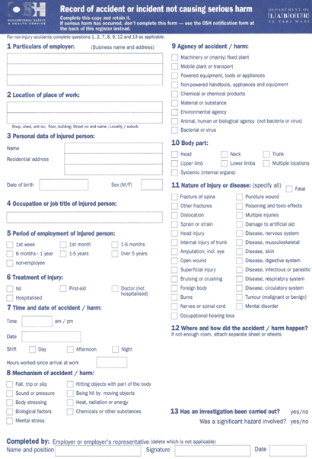

Template - Notifiable death/injury/illness
Click on link to download e-file:
http://www.business.govt.nz/worksafe/notifications-forms/notifiable-events
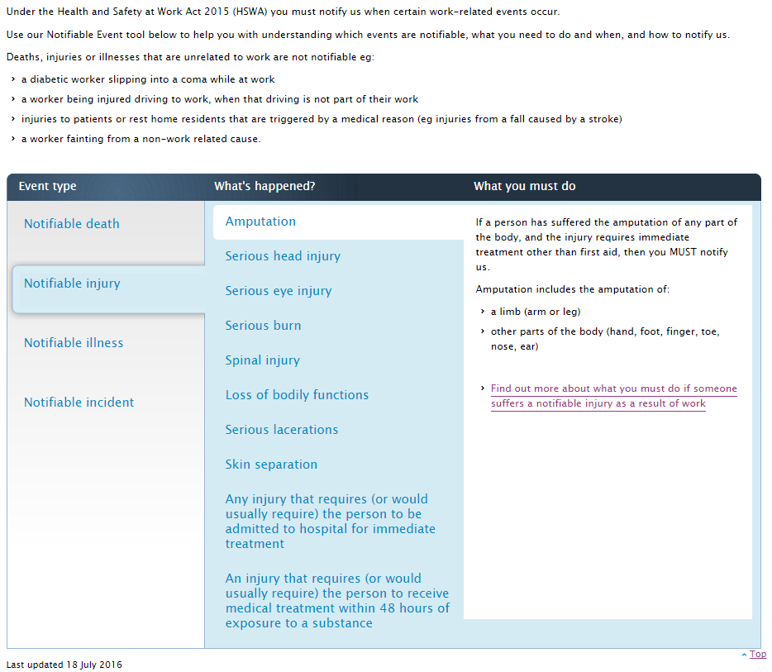

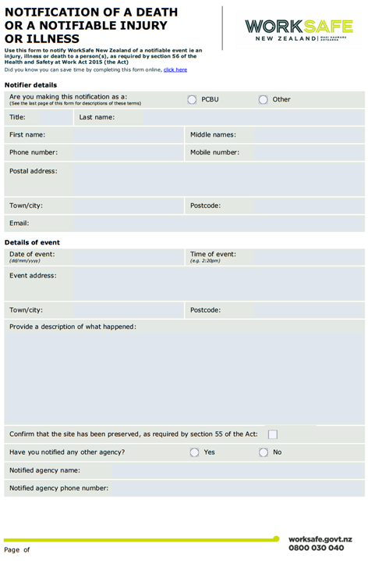
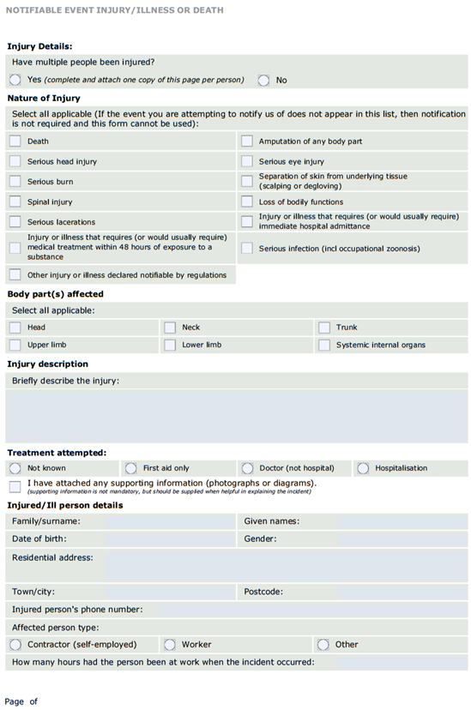
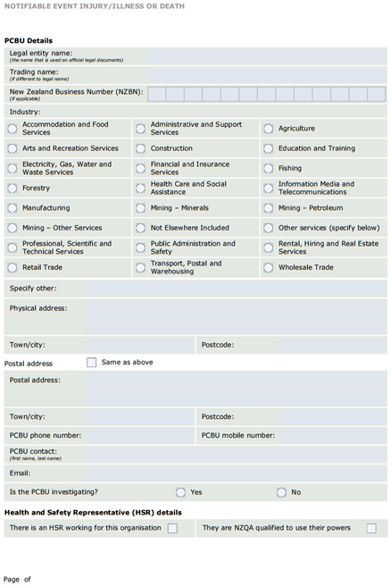

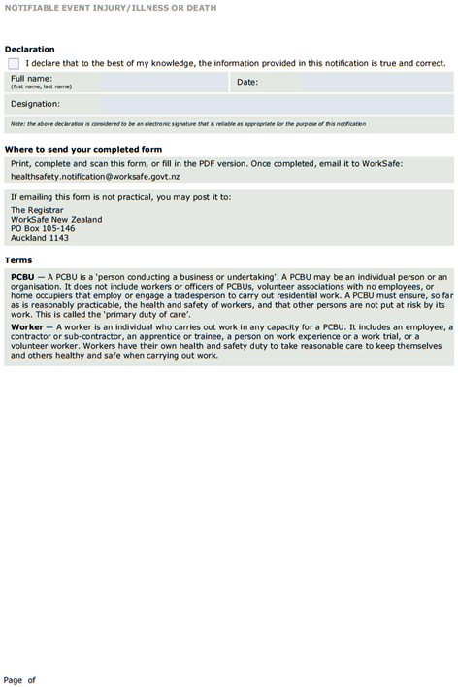

Template - Accident Investigation Form
Click on this link to download the e-file template
http://www.business.govt.nz/worksafe/tools-resources/health-and-safety-templates/form-accident-investigation.pdf/view

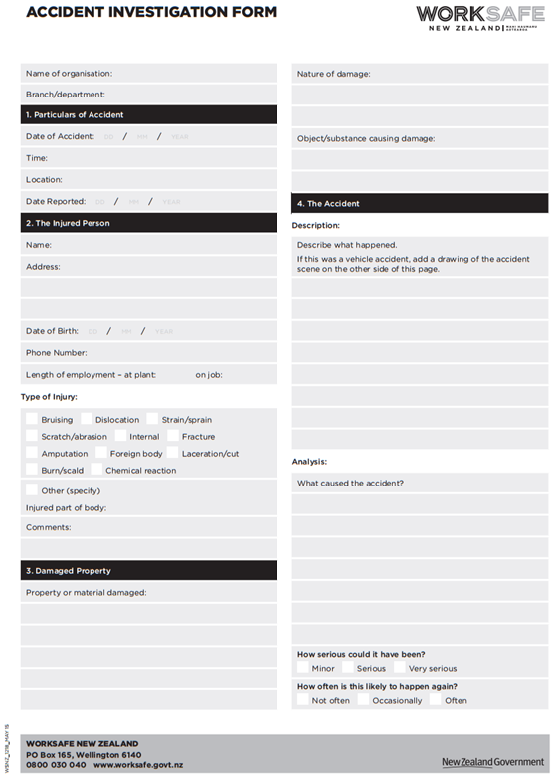
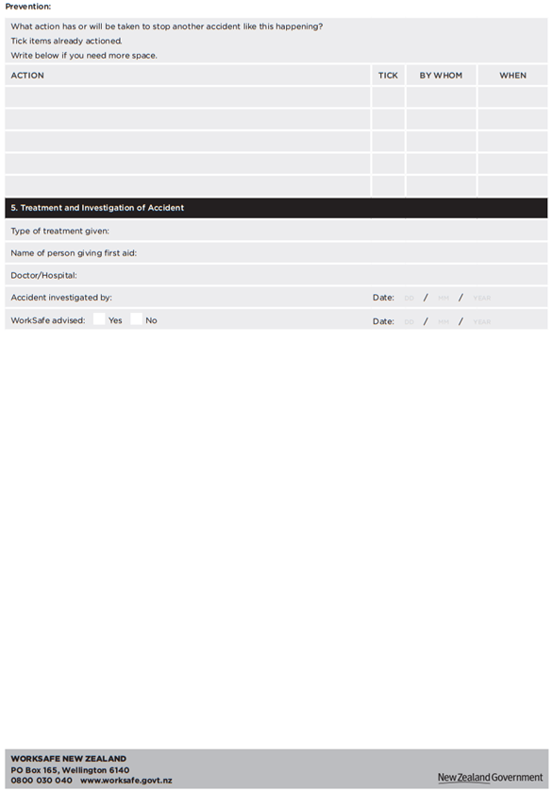

Visitor and Contractor Management

Overview
OBJECTIVE: The PARISH has important legal obligations to monitor and supervise the activities of contractors with regard to the health and safety aspects of their work. When The PARISH as the Principal engages contractors to perform work on their behalf, they have a responsibility to ensure a systematic approach is used to ensure that all contractors, sub-contractors and their employees do not cause harm to themselves or to The PARISH employees while undertaking the work required by the contract.
DESCRIPTION: visitors and contractors are often unfamiliar with the workplace and are used to perform work with specific skills and/or equipment. For these reasons they may not have knowledge of the hazards they may be exposed to, or may introduce new/additional hazards to the workplace and the existing workforce.

Definitions
Worker: in this Act, unless the context otherwise requires, a worker means a person who carries out work in any capacity for the PCBU, including work as:
a) An Employee; or
b) A contractor or subcontractor; or
c) An Employee of a contractor or subcontractor; or
d) An Employee of a labour hire company assigned to work in the person’s business or undertaking; or
e) A homeworker; or
f) An apprentice or trainee; or
g) A person gaining work experience (for example, undertaking a work trial); or
h) A volunteer; or
i) A person of a prescribed class.
For the purposes of subsection (1), a PCBU is also worker if the person is an individual who carries out work in that business or undertaking.
Workplace: in this Act, unless the context otherwise requires, a workplace: person’s business or undertaking; or
a) Means a place where work is carried out for a business or undertaking; and
b) Includes any place where a worker goes, or is likely to be while at work.
In subsection (1), place includes:
a) A vehicle, vessel, aircraft, or other mobile structure; and
b) Any waters and any installation on land, on the bed of or floating on any water
The PARISH Representative: the person responsible for the visitor or the work being undertaken (includes Contractor and Sub-Contractor management).
Premises: premises or workplace under the control of The PARISH, may include a public place.
Visitor: a person attending a workplace temporarily who will remain supervised or escorted at all times. Visitors using the meeting rooms will receive written instructions on all procedures to be followed. In the case of groups of visitors, the group will have a nominated person who will receive the instructions and ensure all members of the
group will be fully briefed.
REFERENCES
www.peoplesafe.co.nz
HS9.1 - Contractor Letter
HS9.2 - Contractor Health and Safety Agreement
HS9.3 - Contractor Induction Checklist
HS9.4 - Approved Contractor List.
HS9.5 - Contractor Monitoring Checklist
HS9.6 - Evaluation of Contractors
HS9.7 - Visitors Register
HS9.8 - Contractor Safety Standards

Responsibilities
Property Manager & Health & Safety Coordinator
- Ensure all Contractors are approved and inducted into The PARISH’s health and safety requirements for Contractors;
- Manage and monitor the safety performance of Contractors; and
- Only use approved Contractors.
Employees
- Report to management any unsafe conditions, activities, behaviours undertaken by Contractors.
Contractors & Visitors
- Follow all of The PARISH’s health and safety requirements as required; and
- Work safely and do not injure themselves or others affected by their work
- Follow the requirements and procedures described in any approved health and safety plans.
- Advise the Principle of any hazards identified, how they will be managed and controlled.
- Advise the Principle of any incident (including Near Misses).

Contractor Selection
The following process is to be followed when selecting and approving contractors:
Contractor Process | The PARISH Process
Contractor to:  - complete and return Contractor Health and Safety Agreement.  - supply evidence of adequate insurance cover (e.g. Public Liability or Professional Indemnity).  The Contractor to supply recent examples of:  - A completed Site Specific Safety Plan  - Work Methodologies (e.g. Safe Work Method Statement, Job Safety Analysis or Task Analysis)  - Evidence of contractor competency for high risk work. | - Identify Contractors with the experience, skill, qualification and certification to do Work.  - Send ‘Contractor Application Pack’ to  the contractor for review, completion and return. Pack to include:  - Contractor Health and Safety Agreement.  - Contractor Safety Standards.  The designated PARISH Representative is to:  - review the evidence supplied and sign final acceptance (for the successful applicant)  - file all information on the Contractor File
PeopleSafe: Electronic documentation can be attached to the Contractor’s file in PeopleSafe and kept as a permanent record.
Where it is assessed that a Contractor or service provider may not be able to meet The PARISH and/or legal requirements in full they must not be engaged unless the operation has no other feasible option available. In this situation a Mitigation Plan must be prepared and approved by The PARISH’s Representative with the appropriate expertise and Limits of Authority before any contract can be awarded.
Note: This process must be completed annually (i.e. the Contractor must resubmit relevant information for re-acceptance and Contractor Employees and Sub-Contractors must be re-inducted).

Contractor Health & Safety Management
The table below shows the minimum requirements to manage Contractor safety performance on site during a Contract.
Contractor minimum requirements | The PARISH minimum requirements
PRIOR - the Contractor must submit appropriate  health and safety documentation for approval. For example:  - Long-term/high risk - Contractors must complete and submit a Site/Contract Specific Safety Plan. This safety plan should also include relevant certification and permits as required. Pre-start Meetings are required for high-risk work and are to be carried out and recorded daily by the  Contractor prior to work starting.  - Short-term/low risk work requires an approved Safe Work Method Statement or similar. | PRIOR - The PARISH Representative to:  - review documentation provided by Contractor  - sign acceptance (if the documentation is acceptable).
DURING - while on site the contractor will:  - Carry out its own internal monitoring of Site Safety  - Complete and file The PARISH Site Safety Assessments, actioning any recommendations as required.  - Be monitored by The PARISH for compliance with the site’s health and safety requirements and any Health and Safety Plan they may have submitted. | DURING - The PARISH Representative to:  - Review compliance during any visits or reviews.  - Monitor Contractor health and safety performance using the Form ‘Contractor Monitoring checklist’.  - Bring any identified corrective actions to the Contractor’s attention and identify/agree resolution and time frames.
Upon any breaches of the site’s health and safety requirements and subsequent inability to comply with reasonable instruction, the contractor will be required to cease their services/work until the matter can be resolved.
AFTER - upon conclusion of a contract, the Contractor will:  - participate in an evaluation of the Contractor’s health and safety performance using the Form ‘Evaluation of Contractors’.  - be notified of any areas of improvement. | AFTER - upon conclusion of a contract, The PARISH Representative will:  - initiate an evaluation of the Contractor’s health and safety performance using the Form ‘Evaluation of Contractors’.  - Notify the contractor of any areas of improvement.
A critical part of this review includes whether the contractor is actively managing health and safety and is responsive to The PARISH’s requests regarding health and safety. For example, the presence of minor injury and near miss reports that have been investigated and actions taken may be more positive than no reports at all.
PeopleSafe: Electronic documentation can be attached to the Contractor’s file in PeopleSafe and kept as a permanent record.

EMERGENCY WORK: emergency work shall be carried out by approved contractors only. If for any reason the approved contractor is unavailable, and the work is urgent (i.e. If it is not completed it will present a risk to people and property), a discussion of the following will be undertaken and agreed with the chosen contractor prior to work starting:
- Sequence of work, associated hazards / risk and agreed controls.
- Environmental risks and controls.
- PPE and Safety Equipment requirements.
- Personnel competency.
- Emergency Procedures.
- Reporting and communication requirements.
- An authorised PARISH representative will be present during the works being carried out.
CONTRACT DOCUMENTS: contractors should be requested to provide evidence of their insurance cover and competency to undertake the work e.g. trade qualifications, licences, etc. prior to their engagement. This will assist in ensuring the work is performed safely and the operations of The PARISH are not adversely affected by the contractor’s inability to perform the work in a safe manner.
CONTRACTOR INDUCTION: short-term and/or low-risk contractors: short-term (for example, at the premises for an hour fixing a plug or a tap washer) shall be signed in and inducted by the person meeting with them. At a minimum the induction shall include:
- Emergency evacuation procedures;
- Requirements to report accidents and hazards;
- Provision of and PPE requirements; and
- No-go areas.
- The contractor will be escorted to the area they are working, monitored and escorted from the premises.
Long-term and/or high-risk contractors: shall be signed in and inducted by an approved inductor.
Important Note: depending on the level of risk and the length of time the contractor will be on site, long-term contractors may also be asked to submit a safety plan for the work they are planning to undertake. The Contractor’s Safety Plan must be approved by The Manager.
Inducted and approved contractors shall have their details recorded in a database and all completed and/or signed documentation shall be filed.

Building Safety

Template: Building Safety Checklist
Use this checklist to assist in maintaining compliance with Part 1 of the Fire Safety and
Evacuation of Buildings Regulations 1992. This checklist is not intended to be used to satisfy the requirements of a Compliance Schedule.
The PARISH Building Safety Checklist
Name: Date: / /
Item | Y | N
Smoke/fire doors - all move freely, in good working order and not obstructed/held open by non-complying devices (wedges,hooks etc)?
Escape routes clear of obstructions (rubbish, storage etc.)?
Fire action notices, exit signs and arrows in place and visible?
Exit doors open easily without the use of a key when the building is occupied?
Fire hose reels are all in good condition and not visually/physically obstructed?
Fire extinguishers are in good condition and not visually/physically obstructed?
Fire fighting equipment serviced within the last 12 months?
Fire alarm manual call points clear and not obstructed?
Housekeeping | Y | N
Flammable storage is appropriate?
Floor/area is neat and tidy?
All rubbish is removed?
Building Warrant of Fitness is current (if applicable)? Expiry Date: / /
All previously noted faults have been rectified?
Defect | Date rectified
 | / /
 | / /
 | / /

Individual Policies

Health & Safety Policy
DEVELOPING A HEALTH AND SAFETY POLICY: ideally the statement should be written by the people within your organisation - they know the organisation best and how it operates. You can seek assistance and advice externally, but essentially, it should be a policy that is appropriate to the needs of your business. Involve your workers in putting the policy together. As well as benefiting from their day-to-day experience of the job, doing so will give you a better chance of getting their commitment to carry out the aims of the policy.
SETTING OUT A POLICY: you can decide on how the policy should be set out. It should be set out in such a way that makes it clear to everyone what is expected of them to comply with the requirements of the policy. In a small organisation it’s likely that a simple statement will be suitable. It’s also likely that the organisation section of the policy will contain only one or two names as most of the responsibilities will be allocated to those people.
INFORMING WORKERS: there are various ways to bring the policy to the attention of workers. If it is short enough, you may decide to give e-mail each worker. Or you could post copies on notice boards or in appropriate places. Whatever you choose to do, you must make sure that you bring the policy to the attention of all workers.
MONITORING AND REVIEW: monitoring that the policy is still effective is vital. There are many ways that this can be done, including carrying out spot checks or safety inspections sing prepared checklists. More formally, effective monitoring can be achieved through audits and by reviewing management reports and accident
Investigations.
WHY WE NEED POLICIES: you have identified the hazards, the next step is to eliminate or minimise them. With having policies in place you are training your workers to be aware and minimise these hazards. We have examples following this page to get you started.
EXAMPLES: this is not an exhaustive list. You need to review your hazards and discuss if a policy is required. This ensures a clear understanding of expectations for both you and the workers in your care. These policies have come from the hazards you have identified and the policy is setting the standards.

Discomfort/Pain/Injury (DPI) Prevention Policy
BACKGROUND: discomfort/pain/injury (DPI) has been previously referred to as occupational overuse syndrome (OOS), which was earlier referred to as repetitive strain injury (RSI).
POLICY STATEMENT: DPI is a collective term for a range of conditions (including injury) characterised by discomfort or persistent pain in muscles, tendons and other soft tissues. Every case of DPI has the potential to be classified as a significant hazard because the condition may cause ‘Serious Harm’. Therefore the risk factors for DPI need to be controlled by eliminating the hazard if at all possible, or else by isolating or minimising the hazard.
PURPOSE: To provide systems and procedures for proactively managing the risk factors that may contribute to a range of occupational overuse type conditions.
RESPONSIBILITIES
The [Manager or Designated Person] is responsible for:
- Taking all practical steps to ensure that there is compliance with WorkSafe New Zealand.
- Ensuring all workers at risk attend a DPI awareness training session in their first month.
- Encouraging workers to report any work-related pain to the [Manager or Designated Person].
- Ensuring the work environment of any workers who do develop symptoms is monitored.
- Facilitating an early return to work for any worker who has been absent through a DPI.
Workers are responsible for:
- Reading the DPI awareness information and attending training where required.
- Adjusting workstation equipment to maintain a comfortable body position.
- Taking breaks away from the workstation and practicing micro-pauses as appropriate.
- Reporting early symptoms to the [Manager or Designated Person] – preferably before visiting a doctor.
- Participating in an early return to work programme if applicable.
PROCEDURE
Pre-employment procedures: the [Manager or Designated Person] will seek to establish if the prospective worker suffers from any gradual process injury that a particular job may aggravate or contribute to by checking the statement on the application form. Laptop computers should not be chosen for continuous use at work unless they are plugged into a conventional monitor and/or keyboard.
Existing workers
Individual workers should adjust their own workstation to maintain a comfortable working position, vary tasks, practice micro-pauses and take other breaks. They must report any problems to the health and safety representative, who in turn may request a full workstation assessment from a properly trained workstation assessor. The workstation assessor will work with the worker to recommend changes or adjustments and will provide a brief summary of findings to the worker and the [Manager or Designated Person].
Early warning symptoms should not be ignored in the hope that the pain will go away. If discomfort during work activities persists for more than a few days, action should be taken. By taking action, individuals will be making important progress with regards to stopping the symptoms from worsening and developing into a possibly serious and long-term condition.
STANDARDS
- Approved Code of Practice for the Use of Visual Display Units in the Place of Work
- Guidelines to the Selection and Purchase of Workstation Furniture and Equipment
REFERENCES
- The Health and Safety in Employment Act (1992) and Amendment
- Approved Code of Practice for the Use of Visual Display Units in the Place of Work published by WorkSafe New Zealand, Ministry of Business, Innovation and Employment
- Guidelines to the Selection and Purchase of Workstation Furniture and Equipment
- Accident Reporting and Rehabilitation Policy, Record of Accident, Incident or Serious Harm.

Smoke-free Policy
POLICY STATEMENT: it is a requirement of the Smoke-free Environments Act 1990 that all PCBUs have a written policy on smoking for all areas occupied by the PCBU and frequented by workers. The PARISH management recognises that the use of tobacco and smoking presents a health hazard that can have serious implications for both the smoker and the non-smoker and that smoking habits may have life-long adverse consequences. The PARISH supports a safe and healthy environment.
PURPOSE: this policy was developed to meet the requirements of the Smoke-free Environments Act 1990 and the Smoke-free Environments Amendment Act 2003 and is based on the following principles:
(a) Everyone is entitled to a smoke-free environment in all areas normally used for work.
(b) Everyone who does not smoke, or who does not wish to smoke in their place of work, must as far as is reasonably practicable, be protected from tobacco smoke in their place of work.
(c) The implementation of this policy depends on everyone responding courteously to the desire for a smoke-free environment.

RESPONSIBILITIES
The [Manager or Designated Person] is responsible for:
- Signage: the maintenance of smoke-free signage.
All workers are responsible for:
- Policy adherence: adhering to all aspects of the smoke-free working environment policy.
- Smoke-free buildings: smoking in buildings is prohibited as it endangers the safety of others, creates an unhealthy environment and causes damage to property. In the event that a worker chooses to smoke, a designated area, such as a sheltered balcony outside of the premises, should be used.
- Passive smoking: smoking is permitted in outside areas, providing the smoker keeps their distance from people and opens windows and doors within their close proximity to aid in the protection of others with regards to smoke drift and passive smoking.
- Complaints: complaints regarding smoking and suggestions or complaints regarding a smoke-free environment should be brought to the attention of the [Manager or Designated Person].

Stress at Work Policy
POLICY STATEMENT: The PARISH recognises the responsibility of the PCBU to actively reduce and manage stress in the workplace. Stress may arise from both personal and organisational sources. The PARISH clearly has a degree of control only over the latter, and these guidelines provide a framework for stress management in the workplace.
PURPOSE
- to assist all workers to understand the causes of stress, and work together in ways that encourage positive responses to work demands.
- to enable workers to identify indicators or symptoms of stress and to assess the extent to which they or other individuals are responding positively or negatively.
- to encourage the [Manager or Designated Person] and workers to seek information and early assistance in managing their own stress in a constructive way.
- to provide information and advice regarding the causes and impact of stress in the work environment, and offer ways for managing stress positively.
- to have procedures for dealing with negative stress or distress effectively.
RESPONSIBILITIES
The [Manager or Designated Person] is responsible for:
- Facilitating training and information as required for the [Manager or Designated Person] in effective management practices and styles, covering the nature of stress, and promoting responsible prevention and rehabilitation attitudes towards it as determined by the [Manager or Designated Person]
- Providing access to up-to-date and accessible information on stress
- Adjusting the physical environment, the workload, task design, pacing of work and work schedules to alleviate significant stress/distress for an individual, in full consultation with the individual concerned
- Making free specialist counselling available for workers
All workers are responsible for (where applicable):
- Managing your time and realistically prioritising tasks
- Taking regular, necessary breaks during the day
- Taking leave accrued as time in lieu as soon as practicable
- Not working excessively long hours
- Discussing with your [Manager or Designated Person] the issues that are causing you stress, along with any suggested solutions
- Seeking advice and help from others – talk to partners, friends, colleagues, a professional counsellor or your [Manager or Designated Person] if possible.
BACKGROUND INFORMATION
“Stress arises when a person’s capabilities are overwhelmed by demands”
Every day, individuals are confronted with a variety of demands or ‘stressors’. These may arise from either personal sources (e.g. ill-health, marital discord, family problems, financial uncertainty, or from institutional sources such as work overload or underload, role conflict, lack of control or physical environment). Stressors produce a biochemical response in the body which prepare the body to do what is essential during a stressful situation (in preparation for fight or flight).
The stress response is highly functional and can lead to elevated performance, through constructive and creative responses, increased and well-directed energy, improved morale and motivation, and increased efficiency and effectiveness. Where an individual is exposed to demands that are too intense, frequent or chronic, the stress response can create unhealthy, destructive outcomes (e.g. cardiovascular disease or depression).
There are wide individual differences in the way we each respond to stressors, and
therefore the optimum stress load that maximises performance varies by individual and by task. (The Yerkes-Dodson Law refers to the fact that performance increases with increasing stress loads up to an optimum point, and when the stress load becomes too great, performance decreases.)
COMMON SIGNS
Some common signs of stress in individuals are:
- Headaches, feeling tired, or having difficulty sleeping
- Worrying a lot, feeling anxious and tense for no explained reason
- Having difficulty concentrating, finding it hard to make decisions
- Lower level of confidence, making mistakes, forgetting things
- Feeling impatient and irritable, drinking more alcohol, smoking more.
“Stress is inevitable: distress is not”
CATEGORIES
Organisational stressors can be grouped into four categories:
- Physical: The physical environment in which one works (e.g. temperature, office design, noise, lighting).
- Task: The nature of the work itself, the specific activities assigned to the worker (e.g.
reception, budget management).
- Role: The expectations that others have of one’s role and its function within the organization (e.g. conflicting or ambiguous expectations).
- Interpersonal: The social, personal and working relationships that exist.
PREVENTION
- Allow workers to participate in collaborative decision making.
- Allow workers to exercise as much autonomy and control as is practical.
- Provide training to enable work to be done most effectively.
- Consider job design, job descriptions and performance targets with the aim of reducing unnecessary stressors.
- Consult with workers to identify stressors in the workplace.
- Promote activities that make the workplace healthier, more stimulating and fun.
- Carefully match people to jobs by considering their individual skills, capabilities and needs.
EARLY INTERVENTION
- Act immediately if a worker seems overly stressed.
- Explore whether their stress is in any way job related, discuss ways of alleviating it in the short-term initially, and then focus on the sources of stress to consider long-term solutions.
- Short-term solutions could include sharing tasks amongst other workers, taking leave.
- Long-term solutions should aim to eliminate or minimise the cause of stress where or adopting flexible or reduced hours possible – the preventative strategies outlined above should be used.
REFERENCE
The Health and Safety in Employment Act 1992 and Amendment

Lock-up Policy
PURPOSE: to provide consistent procedures for dealing with situations in which workers must secure the safety of the premises, confidential material and workers when locking up.
RESPONSIBILITIES
The [Manager or Designated Person] is responsible for:
- Ensuring the workers are aware of the procedures when locking up the premises and when working alone.
- Providing workers with sound knowledge of security around the office.

Workers are responsible for:
- Following the below stated lock up procedure at all times.
LOCK-UP PROCEDURES
Last person to leave the building at Close of Play each day is responsible to follow the PARISH Lock-up Procedures [below follows the Chanel Centre as example / replace with your own PARISH procedures]:
1. MacKillop House (prefab’s) - check doors to all rooms are secure, set the alarm located in the staffroom.
2. Main Chanel Centre - check all doors are locked and lights are off, set the alarm at the main foyer entrance prior to locking the main entrance door.
WORKING AFTER-HOURS
Staff to ensure that the building remains locked at all times while working after office hours.
REFERENCES:
goriskresources.com~ps_checklist_security.pdf
cambs-police.org.uk~SelfAssessmentChecklist_v2.pdf
locknet.com~physical-security-audit-checklist

Safe Driving Policy
PURPOSE: to ensure that workers who drive vehicles in the course of their work demonstrate safe, efficient driving skills and other good road safety habits at all times and to maintain all company vehicles in a safe, clean and roadworthy condition to ensure the maximum safety of the drivers, occupants and other road users as well as reduce the impact of company vehicles on the environment – this also applies to personal vehicles used for work.
SCOPE: the policy is applicable to all workers driving both personal and company vehicles for work.
RESPONSIBILITIES
The Manager or Designated Person)is responsible for encouraging safe driving by:
- Forbidding the use of mobile phones in vehicles while driving, except when using hands-free devices
- Encouraging regular breaks while driving
- Ensuring the PCBU is informed if existing workers become unlicenced
- Providing Driving Training (as required)
- Providing an instruction card in all vehicles in the event of an accident
- Providing a first aid kit for each organisation vehicle
Workers are responsible for:
- Ensuring they hold a current driver licence for the class of vehicle they are driving and this licence is carried when driving a company vehicle
- Paying for all speeding or infringement fines obtained
- Immediately notifying their [Manager or Designated Person] if their driver licence has been suspended or cancelled or has had limitations placed upon it
- Being responsible and accountable for their actions when operating a company vehicle or driving for the purposes of work
- Displaying the highest level of professional conduct when driving a company vehicle
- Ensuring vehicle has current WOF and Registration
- Complying with traffic legislation when driving
- Assessing hazards while driving and anticipate ‘what if’ scenarios
- Driving within the legal speed limits, including driving to the conditions
- Wearing a safety belt at all times
- Never driving under the influence of alcohol or drugs, including prescription and over the counter medication if they cause drowsiness - to do so will merit disciplinary measures
- Adhering to the legal requirements for driving with regards to the use of substances (e.g. alcohol and other) - to do so will result in disciplinary measures.
- Avoiding distraction when driving – the driver will adjust car stereos/navigation devices/mirrors etc before setting off, or pull over safely in order to do so.
- If a worker is driving their own vehicle for the purposes of work, the same policies apply. In addition:
  - The car must be legally registered, warranted and insured for the purposes of work – the worker must show evidence of this on request.
  - The worker must not carry loads for which the vehicle is unsuited, nor may they carry more passengers than for whom there are seat belts.
DEFINITIONS: a vehicle is any means in or by which someone travels or something is carried or conveyed; a means of conveyance or transport; a motor vehicle.
REFERENCES
http://www.nzta.govt.nz/resources/roadcode/
http://www.newzealand.com/int/feature/driving-road-rules-and-safety/
http://www.newzealand.com/int/feature/driving-in-new-zealand/
http://www.nzta.govt.nz/resources/roadcode/about-driving/dealing-with-hazards.html
http://www.aa.co.nz/about/safety-on-the-roads/decade-of-action/four-ways-to-be-a-safer-driver

Harassment & Bullying Policy
PURPOSE: the purpose of this policy is to support a workplace that is free from harassment, discrimination and bullying.
SCOPE: this applies to all workers whether at the workplace of The PARISH or out in the field at other workplaces, as the work requires.
Harassment is prohibited.
HARASSMENT DEFINITION: harassment occurs when someone is made to feel intimidated, insulted, or humiliated because of age, disability, sexual preference, religion, skin colour or ethnicity, gender including pregnancy, marital status, family/carer’s responsibilities, or any other characteristic specified under anti-discrimination or human rights legislation.
EXAMPLES OF HARASSMENT: telling insulting jokes about particular racial groups or genders; sending offensive or insulting emails; displaying offensive posters or screen savers; making derogatory comments about someone’s race or religion.
SEXUAL HARASSMENT: sexual harassment is also prohibited. It includes any unwanted sexually related behaviour that, in the circumstances a reasonable person would be offended, humiliated or intimidated by. Sexual harassment may include making obscene or sexually suggestive remarks or jokes; intrusive enquires into a worker's private life; unwanted body touching or physically molesting a person.
Usually harassment and sexual harassment constitute an ongoing series of events, however legally, just one act can constitute harassment.
Harassment: means any unwelcome comment, conduct or gesture that is insulting,
intimidating, humiliating, malicious, degrading or offensive. It might be repeated or an
isolated incident but it is so significant that it adversely affects someone's performance, contribution or work environment. It can include physical, degrading or threatening behaviour, abuse of power, isolation, discrimination, sexual harassment and racial harassment.
BULLYING
DEFINITION: bullying means unreasonable behaviour, repeated over time, which is deliberate and intended to humiliate, undermine or otherwise have a detrimental effect on the recipient),even though it may not be unlawful.
Workplace bullying is a form of harassment that, until recently, fell outside most current legal definitions of discrimination and harassment. It relates to a misuse or abuse of power in relationships between people. It includes the repeated less favourable treatment of a person by another or others in the workplace. It includes behaviour that intimidates,offends, degrades or humiliates a person, and is unreasonable in the circumstances.
EXAMPLES: physical: swearing; shouting; slamming doors; psychological: silent treatment; assigning meaningless tasks unrelated to the position; deliberately withholding information needed for effective work performance
Bullying IS NOT reasonable management action including:
- Setting reasonable performance goals, standards and deadlines
- Providing constructive feedback on work performance or behaviours
- Following counselling or disciplinary policies and procedures
- Differences of opinion
- Poor or bad management practices
- An interpersonal conflict
- A one-off incident (e.g., outburst of temper)
VICTIMISATION
Victimisation is defined as a person or group of people retaliating or making reprisals
including dismissing or harming the employment of those who submit a complaint about harassment, bullying or discrimination. Victimisation is prohibited behaviour and persons who victimise others may be subject to prosecution similar to that for bullying or Harassment.
DISCRIMINATION
Discrimination occurs when someone or a group of people is treated less favourably or unfairly because of their disability, Race or religion, age, gender including pregnancy, marital status, family/carer’s responsibilities. This list is not exhaustive.
Workplace discrimination can occur during the following activities and circumstances: recruitment and selection of workers; terms, conditions and benefits offered through employment; who is offered training and what sort of training is offered; who is considered and selected for transfer, promotion, retrenchment or dismissal.
As well as being against the law, discrimination in the workplace is also against the organisation's policies and values.
RESPONSIBILITIES
The [Manager or Designated Person] is responsible for:
- Providing a safe working environment free from discrimination and harassment
All workers are responsible for:
- Avoiding behaviours which may be perceived by others as bullying or harassment
- Raising concerns about any behaviours of other workers which they perceive as bullying or harassment
- Reporting harassment directly affecting them to their [Manager or Designated Person]
- Helping create a safe working environment free from discrimination and harassment by ensuring they do not harass or discriminate against any person within the workplace
HARASSMENT REPORTING PROCESS
The process to report harassment, bullying or discrimination within the workplace is as follows:
1. Report to your [Manager or Designated Person] as soon as it occurs
2. If you are not comfortable advising your [Manager or Designated Person], directly
3. An investigation into this behaviour will be actioned.
4. You will be advised of the process as it happens.
REFERENCES
http://www.legislation.govt.nz/act/public/1997/0092/latest/DLM417078.html - Harassment Act 1997
http://www.legislation.govt.nz/act/public/1993/0082/latest/DLM304212.html - Human Rights Act
http://www.legislation.govt.nz/act/public/1961/0043/latest/DLM327382.html - Crimes Act 1961
http://www.legislation.govt.nz/act/public/1993/0028/latest/DLM296639.html - Privacy Act 1993

Disruptive Persons Policy
POLICY STATEMENT: workers are to understand how to protect themselves if a situation arises, beyond their control.
RESPONSIBILITIES
The [Manager or Designated Person] is responsible for:
- Ensuring workers are aware that this kind of behavior will not be tolerated and they are to feel that their safety and health is paramount to the PCBU.
- Taking reasonably practicable steps to ensure workers are aware of what to do to protect themselves, should the need arise.
- Providing assistance as required at the time of an incident and during rehabilitation, as required.
Workers are responsible for:
- Ensuring their own actions or inactions do not harm themselves or others
- Being aware of policy and who to seek assistance from when required
- Providing information if they feel unsafe with any client or at any client premises
- Reporting any incident that occurs and completing incident forms for the H&S register
PROCEDURES
Workers are not expected to take verbal or physical abuse from any person. If a situation arises within the workplace boundaries, you are to follow the procedures outlined below:
- Remove yourself from the incident and get into a safe position; and/or
- Call for help; and/or
- Call 111 for Police assistance (or ambulance if required); and/or
Phone the office and advise the situation, ask if any other workers can assist or are able to collect you or your car if required.
REFERENCES
http://www.victimsupport.org.nz
http://www.police.govt.nz/contact-us/how-report-crime

Manual Handling Policy
PURPOSE: to provide a starting point for the identification, assessment, prevention and control of hazards and risks associated with manual handling in the workplace.
SCOPE: the policy is applicable to all workers.
RESPONSIBILITIES
The [Manager or Designated Person] is responsible for:
- identifying the manual handling tasks that are likely to be a risk to health and safety
- re-assessing the risks on a regular basis, taking steps to control those risks and reviewing the effects of controls. The code of practice for manual handling provides a method that can be used to analyse such tasks in order to establish the healthiest and safest ways of preventing harm to workers
- providing information and training for workers about the hazards they are exposed to or that they may create and what controls are in place.
Workers are responsible for:
- taking all reasonable and necessary precautions for their own health and safety
- being familiar with current best practice for manual handling, including use of equipment.
DEFINITION: “Any activity requiring a person to lift, lower, push, pull, carry, throw, move, restrain, hold, or otherwise handle any animate, or inanimate object” (Source: The Code of Practice for Manual Handling published jointly in June 2001 by WorkSafe New Zealand and ACC).
REFERENCES
Code of Practice for Manual Handling WorkSafe New Zealand (Ministry of Business, Innovation and Employment and ACC)
Manual Handling Hazard Control Record (Worksheet, WorkSafe New Zealand and ACC)
Manual Handling: A Work Book (Department of Labour)
Helpful Advice on Managing Your Acute Low Back Pain (ACC)
Active and Working (National Health Committee and ACC)
Acute Low Back Pain Management (National Health Committee and ACC) that of others, when carrying out manual handling tasks

Rehabilitation Policy
POLICY STATEMENT: The PARISH is committed to initiating vocational rehabilitation programmes whenever appropriate for work-related personal injury and for non-work personal injury (excludes contracted workers who fall outside the definition of ‘worker’). The aim is to assist optimum recovery, early return to work and resumption of the worker's normal lifestyle without undue delay. The benefits of rehabilitation are greatest when the process is begun as soon as possible.
Workers are expected to participate fully in their own rehabilitation programme, which will be established through a consultative approach. The injured person is entitled to support advice and representation from their nominated representative. Medical information will be obtained with formal consent from the workers and will be treated confidentially.
PURPOSE: to proactively manage the early return of workers, through planned rehabilitation, to as normal a life as possible, having regard to the consequences of the personal injury.
SCOPE: the policy is applicable to all workers.
The [Manager or Designated Person] is responsible for:
- Identifying suitable alternative duties, where possible, to enable an early return to work for the worker
- Confirming that a rehabilitation plan is established, if appropriate, following a lost time accident
- Monitoring the worker's progress towards recovery and the suitability of the alternative duties and/or rehabilitation programme.
- Taking steps to see that appropriate levels of confidentiality are maintained consistently with the principles of the Privacy Act 1993
- Reviewing health and safety management after a critical event, or if there is a change in work procedures or health and safety policy
- Acting as the health and safety representative and person responsible for liaison with ACC on behalf of your organisation
Workers are responsible for:
- Participating in an appropriate rehabilitation programme, including a return to work programme which requires alternative duties or partial hours.
- Providing ongoing medical certificates to the [Manager or Designated Person].
PROCEDURES
Early return to work for full-time and part-time workers
A worker who has experienced work-related personal injury and who has taken time off to recover will be supported in a return to work programme as early as possible and in accordance with medical advice. This involves a partnership between the worker and the [Manager or Designated Person], medical treatment providers and others as appropriate. At any stage the worker can choose to be accompanied by a representative or support person. An early return to work may involve a modification of the person’s working environment, alternative duties for a temporary period, and/or changes to the normal hours of work.
Medical information
The worker must give a copy of their completed ACC forms and/or medical certificate, from the treatment provider (this must be a registered medical practitioner if lost time is involved), to the [Manager or Designated Person].
The medical certificate will state the workers capacity or incapacity for work and specify a date for review (second visit) by the treatment provider. Selected or restricted activities may also be specified for a certain period of time. If the injured person is off work for more than seven consecutive days they must provide a medical certificate confirming they are ‘fit for work’ to the [Manager or Designated Person].
Capacity to work and the provision of alternative duties
The provision of suitable alternative duties is an essential part of rehabilitation. Alternative duties are aimed at providing appropriate and productive work while a worker rehabilitates to his/her former role. This is a proactive approach to enable workers to return to work as quickly as possible and maximise the chances of full recovery.
The [Manager or Designated Person], in consultation with others as appropriate, will try to identify suitable alternative duties after considering:
- The nature and severity of the illness/injury
- The medical information provided and the restrictions imposed by treatment providers
- The previous work undertaken by the worker
- The predicted timeframe for rehabilitation (if known).programme which requires alternative duties or partial hours
Regular review
The [Manager or Designated Person] will review the rehabilitation programme in
consultation with the worker at regular intervals, usually every 2 weeks, involving others as appropriate. Where uncertainty exists regarding the suitability of duties being performed or where the progress of a worker is slower than anticipated, the [Manager or Designated Person] will seek additional professional assistance as appropriate.
Alternative Placement or Permanent Disablement
Where at any point it becomes clear that a worker will be unable or is unlikely to return to former duties as a result of work-related personal injury, The PARISH will explore the possibility of suitable alternatives with the worker. When a worker’s personal injury is so severe that it prevents him/her from returning to their former position and all available options have been fully explored, then termination of employment will be considered in accordance with the relevant employment agreement.
DEFINITIONS
Rehabilitation: means a process of active change and support with the goal of restoring the workers health, independence and participation to the maximum extent practicable. It comprises treatment, social rehabilitation and vocational rehabilitation.
Rehabilitation Plan: means an individualised rehabilitation programme to facilitate the early and safe return of the worker to the same or equivalent duties as those previously performed on a long-term basis.
Alternative Duties: are early return to work interventions. They may include alternative work, or other forms of action appropriate for the worker. These duties are a temporary modification of the worker’s work tasks. They must not aggravate the personal injury or delay healing, must be compatible with the business of the organisation, and be subject to regular review. A worker may be fit for alternative duties from the occurrence of the personal injury or when improvement has occurred following a period of being unfit for Work.
Serious Harm: means resulting in a condition that amounts to or results in permanent loss of bodily function, or temporary severe loss of bodily function and/or any harm that causes the person to be hospitalised for a period of 48 hours or more.
REFERENCES
Injury Prevention, Rehabilitation, and Compensation Act 2001, Privacy Act 1993. Human Rights Act 1993, Health and Safety in Employment Act 1992 and Amendment.

Risk Assessment Management Examples

Encounter Day - CYO Bush Walk
Risk Assessment Management Strategy
ENCOUNTER DAY - Bush Walk |  |  | 
Catholic Youth Office (CYO) Adult:Minor Ratio |  | 1:8
Date |  | August 2016
Person Accountable |  | Alex Bailey  CYO  021 228 4522
Hazards Identified
Hazards | Significance  1 = minor  2 = major  3 = life changing | Eliminate/  Isolate/  Minimize | Action
Slippery Tracks | 1 | Minimize | Highlighted to group
Uneven Terrain | 2 | Minimize | Highlighted to group
Vegetation | 1 | Minimize | Highlighted to group
Steep Banks | 3 | Isolate | Group to stay on track
Water | 2 | Minimize | Highlighted to group.  Caution used.
Risks specific to activity
(potential losses, accidents, injury, other forms of damage, risk)
Major injury | Dislocation | Getting lost | Stings/Allergies
Broken bones | Dehydration | Hypothermia | Cuts, grazes and bruising
Causal factors |  | Risk reduction strategies
People  - Poor communication between leaders and students  - Poor group management  - Students not obeying instructions  - Pre-existing medical conditions  - Poor safety briefing  - Slips trips and falls |  | - Thorough safety briefing given by CYO staff, hazards identified and communicated to the group  - A responsible adult will be appointed to be ‘tail end charlie’  - Group walks at an appropriate pace for their ability level  - All medical conditions are made known to staff and emergency medication accessible if required
Equipment  - Inappropriate footwear/clothing  - Lack of First Aid equipment  - Insufficient food/fluids  - Damage to walking track |  | - Appropriate briefing of adequate clothing/footwear  - Suitable First Aid for activity carried by CYO staff  - Children briefed on staying on the track
Environment  - Littering and abuse to natural environment  - Adverse weather changes  - Excessive sun, wind or rain  - Difficult terrain  - Conditions of track inappropriate for activity |  | - Compliance with NZ Environmental Care Code  - Check weather forecast before activity  - Making sure students are aware of conditions and have catered for it. Sunscreen/hat/water bottle  - Track walked the day before to check track conditions
Environmental Care Code
Protect Plants and Animals: treat New Zealand's forest and birds with care and respect. They are unique and often rare.
Remove Rubbish: litter is unattractive, harmful to wildlife and can increase vermin and disease. Plan your visits to reduce rubbish, and carry out what you carry in.
Bury Toilet Waste: in areas without toilet facilities, bury your toilet waste in a shallow hole well away from waterways, tracks, campsites and huts.
Keep Streams and Lakes Clean: when cleaning and washing, take the water and wash well away from the water source. Because soaps and detergents are harmful to water-life, drain used water into the soil to allow it to be filtered. If you suspect the water may be contaminated, either boil it for at least 3 minutes, or filter it, or chemically treat it.
Take Care With Fires: portable fuel stoves are less harmful to the environment and are more efficient than fires. If you do use a fire, keep it small, use only dead wood and make sure it is out by dousing it with water and checking the ashes before leaving.
Camp Carefully: when camping, leave no trace of your visit.
Keep to the Track: by keeping to the track, where one exists, you lessen the chance of damaging fragile plants.
Consider Others: people visit the backcountry and rural areas for many reasons. Be considerate of other visitors who also have a right to enjoy the natural environment.
Respect Our Cultural Heritage: many places in New Zealand have a spiritual and historical significance. Treat these places with consideration and respect.
Enjoy Your Visit: enjoy your outdoor experience. Take a last look before leaving an area; will the next visitor know that you have been there?

SetFree Catholic Youth Festival
Risk Assessment Management Strategy
SetFree Catholic Youth Festival
 | Date | 18-20 March 2016
 | Venue | South Waikato Sports Centre  Papa O Te Aroha Marae  St Pius X Catholic Church
1. 270 Total people attending the Festival
2. All activities will be onsite (at the venues above)
3. All 270 participants will be using the onsite accommodation
 | Contacts | Alex Bailey, Youth Director, 021 228 4522  Briege Koning, Youth Coordinator, 021 228 4523  Peter Richardson, Diocesan Pastoral Team Leader, 021 896 012
Risks |  | Guidelines to manage risk
Participants get lost |  | Make Leaders aware they are responsible for their young people  Campsite boundaries are explained  Maps provided  Clear signage
Leaving camp, day visitors, ministers, speakers/presenters visiting |  | 1. Participants (under 18) must stay at camp unless:  - A pass has been granted PRIOR to camp  - Injured  - Expelled  2. Speakers/presenters or activity coordinators who are not staying onsite, must:  - have coordinated travel times with camp director in advance  - sign in and sign out at registration desk
Injury |  | Campers are supervised through all activities  Ensure all games and activities are being run appropriately and rules are being followed  Qualified First Aider is always available  Appropriate first aid supplies are available
Illness |  | Medical information in registration, with relevant info given to cook and medical officer  Qualified First Aider is always available  Appropriate first aid supplies are available  Cleanliness is used in bathrooms and food preparation
Home-sickness |  | Leaders provide an inviting and respectful environment.  Camp parents care for participants who are suffering from home-sickness
Behavioural - violence |  | Rules to be on website and given to leaders before camp to share with participants.  Small Group Leaders are responsible for their group’s behaviour  Campers are reminded of the rules from the mainstage  Process to follow if a young person informs a youth leader of violence:  - Ensure immediate safety if needed  - Take injured party to first aid office  - Inform Camp Director  - The seriousness of the offence will be assessed  - If the victim wishes to press charges, or the Camp Director wants to involve the Police, the Police will be contacted, parents and key Youth Leader will be contacted.  - Camp Director to record incident in Incident Reporting form
Behavioural - sexual activity, consensual or rape |  | Rules to be on website and given to Leaders before camp to share with participants.  Campers are reminded of the rules from the mainstage  If two young people who are not married have consensual sex:  - Key Youth Leader and parents will be advised of zero tolerance of sexual activity.  - Young people will be sent home.  - If one or both parties are under 16, the law has been broken and the Police may be contacted.  Sexual abuse is against the law. If a young person informs a Youth Leader of a sexual attack:  - The Youth Leader must take it seriously  - If the young person is in danger or unsafe, act to ensure immediate safety  - Inform camp director  - It is not the youth Leader’s role to do more than this  - Camp Director will call the Police  - Alleged victim to be kept safe until Police arrive  - Police will contact parents and decide next course of action  - Camp Director will record incident in Incident Reporting form
Behavioural - theft, vandalism, alcohol or drugs |  | Campers are reminded of the rules from the mainstage  If a Youth Leader becomes aware of an act of theft or vandalism, or drugs or alcohol is found and the perpetrator is known:  - Advise key Youth Leader and Camp Director  - Camp Director will investigate and may involve Policy  - In the event of theft or vandalism, the key Youth Leader may need to contact parents to arrange the property to be repaired or replaced.
Emergency |  | At first meeting, participants will be verbally told what to do in an emergency and where emergency exits are for main meeting  Assembly points will be noted in main meeting  In the event of emergency, everyone goes to the assembly point, and key Youth Leaders account for their group
Bad Weather |  | Have back-up Plans for all activities
Lost Property |  | Advise participants from mainstage as to where the lost property office is.  Lost property should be handed into office  Property not claimed a month after camp will be donated to a local charity

